Week 3 / Week 4 Term 2
Careers Newsletter
Important Information and Dates:
Year 8
- In2UNI Periods 3 and 4 Wednesday 23rd May- 8V and 8I

Year 10
- NAPS Naval Aviation Day – 31st May (only 18 places available) notes from Careers Hub
- UOW Talk in the Library – Subject Selection 9:00am -10:00am – 4th June
- Future Finder Day – University of Wollongong – Shoalhaven Campus – 7th June
- Taste of Tafe – 20th June
- Shoalhaven Careers Expo Day – 26th June
- Subject Selection Evening – 26th June
- UOW Shoalhaven Campus - UAC information Sessions – public – 25th July 4pm – 5:00pm

Year 12
- UMAT applications – Registrations close 5:00pm AEST 1st June 2018, UMAT exam – 25th July 2018 https://umat.acer.edu.au/
- LAT - Law Admissions test – Registrations for LAT have opened – Test – 25th September www.law.unsw.edu.au/future-students
- UOW Shoalhaven Campus – Information Session 4th June
- Early Entry Admissions starting to OPEN at many Universities.
- UNI OPEN Days 2018 – Dates www.uac.edu.au
- UAC information Session – UOW Shoalhaven Campus 4th June
- Responsible Service of Alcohol (RSA)– 29th June, followed by Responsible Service of Gambling (RSG) September 7th
- UOW Shoalhaven Campus - Year 12 UAC information Sessions – 25th July - public - 5:30 – 7:00 pm
- Year 12 UAC information Session 9th August – Parent –Teacher Evening Year 11 and 12 Vincentia High School
- UOW Open DAY – 11th August

Tafe Information
NEW course: Certificate II in Skills for Work and Vocational Pathways FSK20113
Information Sessions for Semester 2, 2018 – Friday the 25th May 2018 at 10:00am, Nowra Campus, Bomaderry, Room MG10.
This information session is for students, carers, teachers, case workers and anyone interested in doing this course in Semester 2, 2018
The application process for young people under 17yrs who have not completed year 10 will be explained.

- White Card Course – 22nd June – please register at the Careers Hub!
- BUSH FIRE TRAINING INFORMATION SESSION Tuesday 12th June 1:32pm (Period 6) Year 10 Students - please register at the Careers Hub!
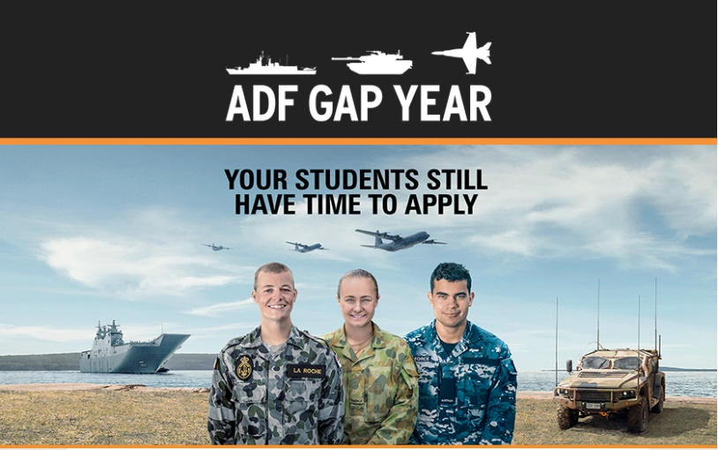
- Thursday 28th June Nowra Defence Careers Information Session
Through an ADF Gap Year you'll:
• | Gain valuable skills and work experience
• | Enjoy a great salary package plus free healthcare
• | Live a varied, active and healthy lifestyle
• | Make friends with like-minded people
• | Get the opportunity to see more of Australia

https://app.defencejobs.gov.au/mp/messenger/webversion/?messageSend=4adb1477-ac69-44f7-a5f0-decf5d0a9f8b&recipient=66fa57aa-de74-46ac-8e17-6281b734a0f5&contenttype=Html

JOBS
HVTC – Hunter Valley Training Company – www.hvtc.com.au/ - advertising soon for traineeships and apprenticeships, please keep an eye on their website, possible opportunities include: Business Administration, Fitter and Construction - hosted by Council.
- House Cleaner – Cash $20:00/ Hour

- Available vacancy at Reece Plumbing Nowra - https://reece.wd3.myworkdayjobs.com/en-US/ReeceCareers/job/NSW---Nowra---19-Haigh-Avenue/ASBA---Plumbing-Nowra_R-00001526. This application page has further information about the role responsibilities and eligibilities if Year 10 students that are interesting in applying.
