CAREERS NEWSLETTER
Term 3: Week 1/2

SPECIAL ADDITION FOR YEAR 12
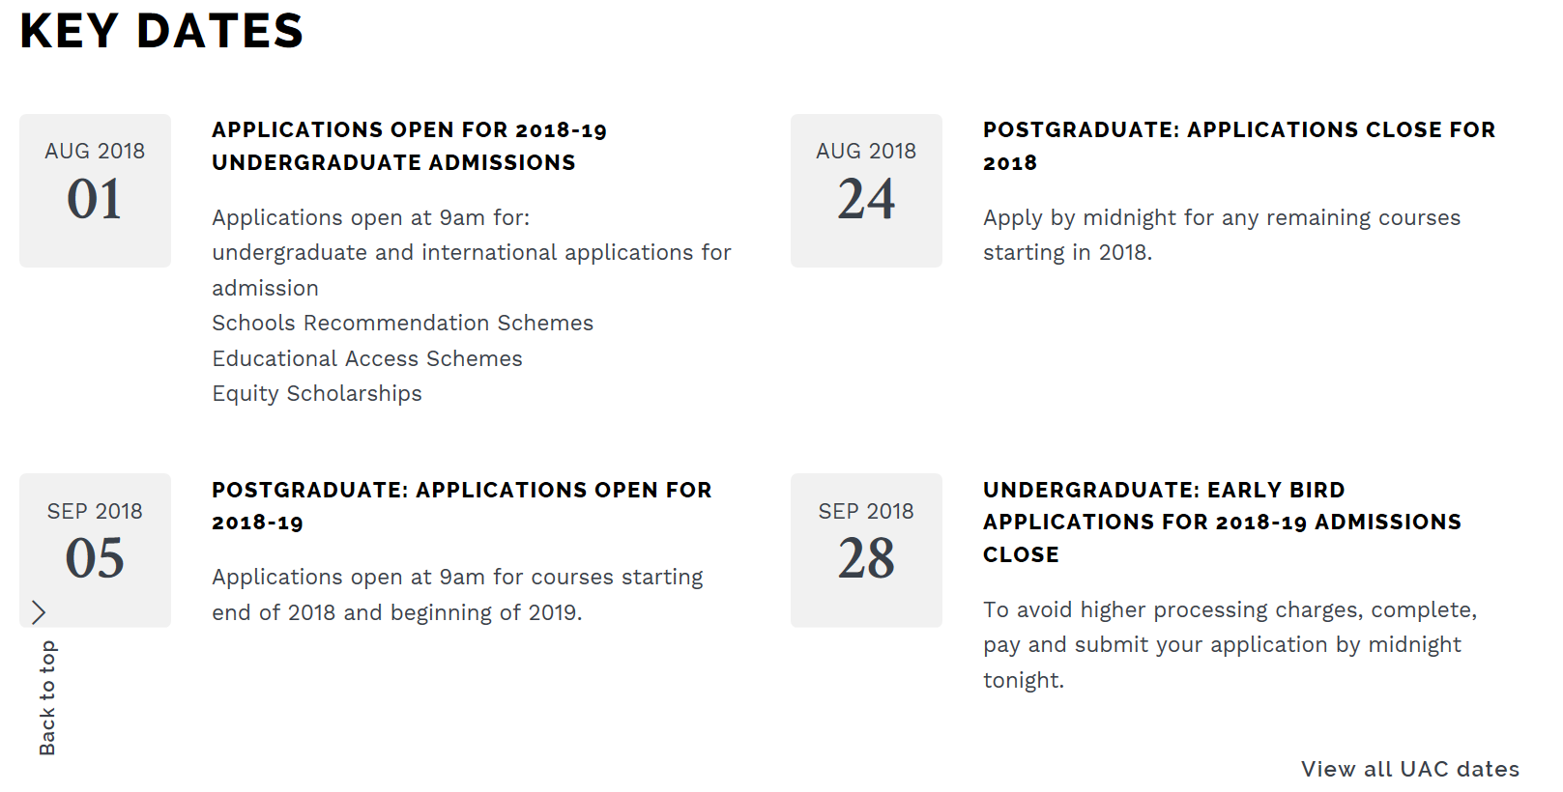

EARLY ADMISSION OPEN 1st August 2018

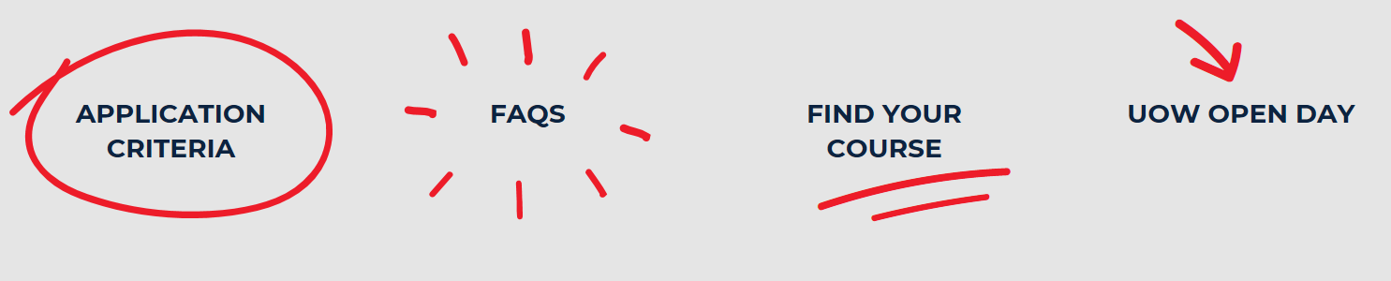

SUBJECT SELECTION

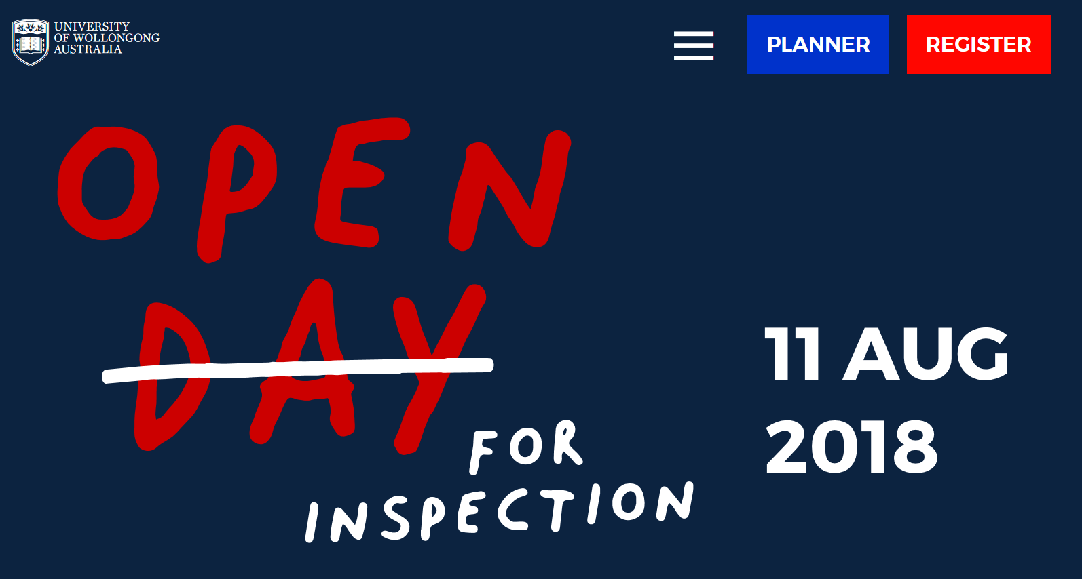

Don’t Forget – Thursday afternoon Tutorial session in the Library – Period 5 and 6
Questions to think about?
- Key Dates for 2018 admissions
- What is an ATAR?
- Are you ATAR eligible?
- What is Scaling?
- Educational Access Scheme
- Scholarships
- Offers
- Bonus Points – Adjustment Factors
- How many courses can I apply for?

Please do not hesitate to contact: Mrs McNeil – Careers Advisor for more information or to arrange an interview time.

